

AutoUpdate with aeLoader using File Name Changes

Presented By


adaept information management
Peter F. Ennis
Revision r1.0.0

September 9, 2005

Table of Contents

Executive Summary 1
Starting Requirements 1
The Application 1
The Loader Command Line 3
The Update Function 4
The Update Function Code 4

Executive Summary
Auto updating is implemented in DSFRC applications using the adaept library: adaeptdblib.mda. This functionality works well but requires control over the application source code as the library is linked into the application. It is not suitable for other applications, such as NoHo Care, that are closed. For this reason a methodology has been developed using aeLoader that will allow the remote updating of the application through changes in the application file name.

A very simplistic overview of the process is that the loader will check for a new version and copy it from the server to the client. The loader will then restart with the new version of the application on the client.

Development is targeted for Microsoft Access .mde applications, of which NoHo Care is specifically used in DSFRC. The methodology will work with any application executable where version changes are part of the file name. Extensions could be added so the process is independent of including version changes in the file name. For example, an application name could cycle through versions that are colors of the rainbow: red, orange, yellow, green, blue, indigo, violet. It could even change randomly. The loader would need a mechanism to remember the last version used on any particular client, however this is beyond the scope of the current implementation.

Starting Requirements
The file name will be in two parts with a special character separator between the application name and its version. In the example below the ‘_‘ character is the separator.

CARE2000_410Patch2.mde
CARE2000_410Patch3.mde
CARE2000_410Patch4.mde
Etc.

A new version release will be indicated from an update information file stored on the network file system. The file used for NoHo is “DSFRC NoHo Update Info.txt” and an example of its contents follow:

APP_NAME: NoHo CARE
#APP_NEW_VERSION:
APP_NEW_FILE_VERSION: CARE2000_410Patch2.mde
APP_UPDATE_USER: pfe, all
APP_UPDATE_END:

The Application
The loader uses two classes that are adapted from the library. These classes are:
aeLoaderUpdateTxtClass
aeLoaderUpdateSetupClass

The setup class sets the global values for the application that are stored in the table:
tblAppSetup
When the application starts is will check if an update is needed. The value of:
blnTheAppLoaderUpdateStatus
will return True when an update is to be performed and a form will display the status of the new application file that is copied across the network.

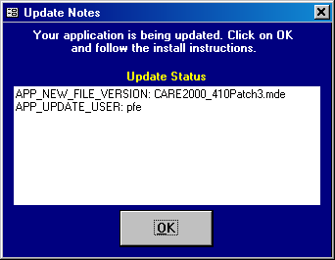

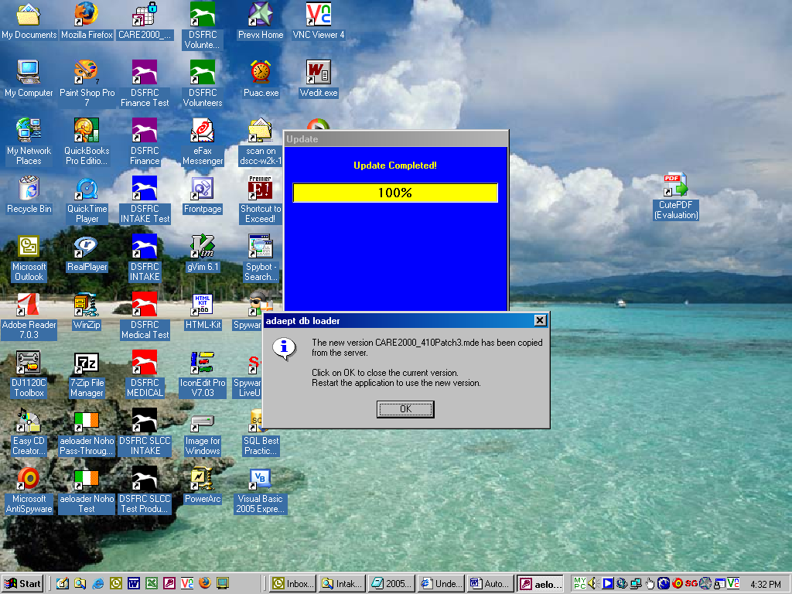

The Loader Command Line

The loader is started from a shortcut with the following command line target, all on one line:

"C:\Program Files\Microsoft Office\Office\MSACCESS.EXE" "\\Dscc-w2k-1\Intake\aeloader.mdb" /wrkgrp "\\Dscc-w2k-1\Intake\DSCC.MDW" /user "NopwdUser" /pwd "nopwd" /cmd "NoHo CARE"

The workgroup is DSCC.MDW and the command that starts the NoHo application “NoHo CARE”.

The Update Function
The operation of the update function is to set blnTheAppLoaderUpdateStatus to be true. The update text file is then checked. If the current application file exists on the client then the function will return false. If a setting in the file indicates the update is turned off then the function will return false.

The Update Function Code
Private Function blnTheAppLoaderUpdateStatus() As Boolean

' What: Function to test all requirenents for program update operation
' Author: (c) Peter F. Ennis
' Created: 2/10/2000
' Passed in:
' Returns: True if system is to be updated.
' Last Mod: 02/22/2000
' 08/24/2004 modify to use test mode from library
' called from frmLoaderUpdateNotes
' 09/12/2004 created as part of class
' 05/06/2005 aeDebugIt caused Invalid File Access Error #75.
' The log file had admin only permissions set from testing
' as admin. Quick fix - set permissions for everyone.
' Correct fix - app should write to log files with admin permissions
' regardless of who the user is.
' 09/06/2005 Modify for aeLoader and Noho

On Error GoTo Err_blnTheAppLoaderUpdateStatus

Dim strFileData As String
Dim strAbsoluteFileName As String
Dim strUpdateID As String
Dim strUpdateID_Param As String
Dim fAppNameCaptured As Boolean
Dim intFileNum As Integer
Dim intTemp As Integer
Dim intTemp2 As Integer
Dim intLoop As Integer

' The Update Info File will be opened to determine how to do the update
' Sample Contents:
'
'APP_NAME: The Application
'#APP_NEW_VERSION:
'APP_NEW_FILE_VERSION: TheNewFile-v100.mde
'# Use ALL for updating all users
'APP_UPDATE_USER: pfe
'APP_UPDATE_END:
'

'MsgBox "aeLoaderUpdateTxtClass: blnTheAppLoaderUpdateStatus: aeUpdateDebug = " & aeUpdateDebug
1 If gstrTheApp = "" Then
2 MsgBox "Incorrect Application Name Setup" & vbCrLf & _
"Please configure and use aeLoaderUpdateSetupClass", vbCritical, _
"aeLoaderUpdateTxtClass: blnTheAppLoaderUpdateStatus"
3 Exit Function
4 End If
5 mstrUpdateText = "" ' Initialize update text string variable
6 strAbsoluteFileName = gstrServerPath & gstrUpdateInfoFile
'MsgBox "aeLoaderUpdateTxtClass: blnTheAppLoaderUpdateStatus: strAbsoluteFileName = " & strAbsoluteFileName
601 intLoop = 1
7 If Not FileExists(strAbsoluteFileName) Then
'MsgBox "strAbsoluteFileName & " NOT FOUND!", vbCritical, _
"aeLoaderUpdateTxtClass: blnTheAppLoaderUpdateStatus"
8 blnTheAppLoaderUpdateStatus = False
9 Exit Function
10 Else
'READ AND ASSIGN THE VALUES AND INFORMATION IN UPDATE INFO FILE
11 blnTheAppLoaderUpdateStatus = True ' Initialize global update flag
12 intFileNum = FreeFile ' Get available file number.
13 Open strAbsoluteFileName For Input As intFileNum ' Open to read file.
14 Do While Not EOF(intFileNum) ' Check for end of file.
15 Line Input #intFileNum, strFileData ' Read line of data.
'Debug.Print strFileData
16 intTemp = InStr(1, strFileData, ":") - 1
'Debug.Print Comment(strFileData)
17 If (intTemp > 0) And Not Comment(strFileData) Then
18 strUpdateID = Mid(strFileData, 1, intTemp)
19 intTemp2 = Len(strFileData) - intTemp - 1
20 strUpdateID_Param = Trim(right(strFileData, intTemp2))
Debug.Print fAppNameCaptured, strUpdateID, strUpdateID_Param, gstrTheApp
21 If strUpdateID = "APP_NEW_FILE_VERSION" And Not FileExists(gstrLocalPath & strUpdateID_Param) Then
22 fAppNameCaptured = True ' Application name found in update file
23 End If
231 If strUpdateID = "APP_NEW_FILE_VERSION" And FileExists(gstrLocalPath & strUpdateID_Param) Then
232 gstrLoaderUpdateAppFile = strUpdateID_Param
233 'MsgBox "233 gstrLoaderUpdateAppFile = " & gstrLoaderUpdateAppFile, vbInformation, _
"aeLoaderUpdateTxtClass: blnTheAppLoaderUpdateStatus"
234 blnTheAppLoaderUpdateStatus = False
235 GoTo Exit_blnTheAppLoaderUpdateStatus
236 End If
'Debug.Print fAppNameCaptured
24 If fAppNameCaptured Then
25 Select Case strUpdateID ' Data definition in Update.txt
Case "APP_NAME"
26
27 mstrAppName = strUpdateID_Param
28 Debug.Print "1> mstrAppName = " & strUpdateID_Param
29 Case "APP_NEW_FILE_VERSION"
30 mstrAppNewFileVersion = strUpdateID_Param
31 Debug.Print "2> mstrAppNewFileVersion = " & strUpdateID_Param & vbCrLf & _
" gstrAppCurrentFileVer = " & gstrAppCurrentFileVer & vbCrLf & _
" aeUpdateDebug = " & aeUpdateDebug
311 gstrLoaderUpdateAppFile = mstrAppNewFileVersion
312 'MsgBox "312 gstrLoaderUpdateAppFile = " & gstrLoaderUpdateAppFile, vbInformation, _
"aeLoaderUpdateTxtClass: blnTheAppLoaderUpdateStatus"
' If new version does not exist locally then update
32 If FileExists(gstrLocalPath & mstrAppNewFileVersion) Then
33 If aeUpdateDebug Then
331 'MsgBox "331" & gstrLocalPath & gstrDebugFile, vbInformation, "gconTHIS_APP_VERSION = " & gconTHIS_APP_VERSION
34 aeDebugIt gstrLocalPath & gstrDebugFile, "mstrAppNewFileVersion = " & mstrAppNewFileVersion
35 aeDebugIt gstrLocalPath & gstrDebugFile, "gstrAppCurrentFileVer = " & gstrAppCurrentFileVer
36 aeDebugIt gstrLocalPath & gstrDebugFile, "NOT UPDATING: No change to file version name"
37 blnTheAppLoaderUpdateStatus = False
38 GoTo Exit_blnTheAppLoaderUpdateStatus
381 Else
382 blnTheAppLoaderUpdateStatus = False
383 GoTo Exit_blnTheAppLoaderUpdateStatus
39 End If
391 Else
40 End If
41 Case "APP_UPDATE_USER"
411 'MsgBox "411 APP_UPDATE_USER strUpdateID_Param = " & "'" & strUpdateID_Param & "'", vbInformation, _
"aeLoaderUpdateTxtClass: blnTheAppLoaderUpdateStatus"
412 If strUpdateID_Param = "" Then
413 blnTheAppLoaderUpdateStatus = False
414 GoTo Exit_blnTheAppLoaderUpdateStatus
415 Else
42 mastrUpdateUsers = GetUserList(UCase(strUpdateID_Param))
43 Debug.Print "3> mastrUpdateUsers = "
44 Dim i As Integer
45 For i = 0 To UBound(mastrUpdateUsers)
46 Debug.Print mastrUpdateUsers(i)
47 Next i
'IF NO DEFINED UPDATE USER THEN DO NOT UPDATE
48 If mastrUpdateUsers(0) = "NONE" Then
49 blnTheAppLoaderUpdateStatus = False
50 GoTo Exit_blnTheAppLoaderUpdateStatus
51 End If
'IF NOT ALL THEN TEST FOR LEGITIMATE GROUP NAME THEN TEST FOR LEGITIMATE USER NAME
52 If mastrUpdateUsers(0) <> "ALL" Then
53 mstrTheCurrentUser = UCase(gstrTheCurrentUser)
54 Debug.Print "4> mstrTheCurrentUser = " & mstrTheCurrentUser
' CHECK ALL USERS
55 Dim j As Integer
56 For j = 0 To UBound(mastrUpdateUsers)
57 If mastrUpdateUsers(j) <> mstrTheCurrentUser Then
58 Debug.Print mastrUpdateUsers(j)
59 blnTheAppLoaderUpdateStatus = False
60 Else
61 Debug.Print mastrUpdateUsers(j) & " WILL BE UPDATED"
62 blnTheAppLoaderUpdateStatus = True
63 Exit For
64 End If
65 Next j
66 End If
End If
67 Case "APP_UPDATE_END"
68 Debug.Print "5> " & "APP_UPDATE_END"
69 fAppNameCaptured = False ' Drop out of loop
70 Case Else
71 End Select
72 End If
73 End If
74 If Not Comment(strFileData) And fAppNameCaptured Then ' Create the update text string
75 mstrUpdateText = mstrUpdateText & strFileData & vbCrLf
751 Debug.Print "Loop" & intLoop, mstrUpdateText
76 End If
761 intLoop = intLoop + 1
77 Loop
78 End If
'
79 gstrUpdateText = mstrUpdateText ' Store value in frmLoaderUpdateNotes
80 gstrAppNewFileVersion = mstrAppNewFileVersion
'
81 If blnTheAppLoaderUpdateStatus Then
82 If aeUpdateDebug Then
'MsgBox "82 aeLoaderUpdateTxtClass: blnTheAppLoaderUpdateStatus", vbInformation
83 aeDebugIt gstrLocalPath & gstrDebugFile, vbCrLf & _
"gstrTheApp = " & gstrTheApp & vbCrLf & _
"gstrServerPath = " & gstrServerPath & vbCrLf & _
"gstrLocalPath = " & gstrLocalPath & vbCrLf & _
"gstrUpdateInfoFile = " & gstrUpdateInfoFile & vbCrLf & _
"gstrAppCurrentFileVer = " & gstrAppCurrentFileVer & vbCrLf & _
"gstrUpdateAppFile = " & gstrUpdateAppFile & vbCrLf & _
"gstrLoaderUpdateAppFile = " & gstrLoaderUpdateAppFile & vbCrLf & _
"gstrDebugFile = " & gstrDebugFile & vbCrLf & _
"gfUpdateDebug = " & gfUpdateDebug & vbCrLf & _
"_______________________________________________" & vbCrLf & _
"mstrUpdateText:" & vbCrLf & _
mstrUpdateText & vbCrLf & _
"_______________________________________________"
84 aeOpenFrmLoaderUpdateNotes
85 Close #intFileNum ' Close data file.
86 Else
87 aeOpenFrmLoaderUpdateNotes
88 End If
89 DoCmd.Quit
90 End If

Exit_blnTheAppLoaderUpdateStatus:
91 Exit Function

Err_blnTheAppLoaderUpdateStatus:
92 MsgBox "aeLoaderUpdateTxtClass: blnTheAppLoaderUpdateStatus Erl:" & Erl & " Error # " & Err.Number & ": " & Err.Description
93 MsgBox "gstrTheApp = " & gstrTheApp & vbCrLf & _
"gstrServerPath = " & gstrServerPath & vbCrLf & _
"gstrLocalPath = " & gstrLocalPath & vbCrLf & _
"gstrUpdateInfoFile = " & gstrUpdateInfoFile & vbCrLf & _
"gstrAppCurrentFileVer = " & gstrAppCurrentFileVer & vbCrLf & _
"gstrUpdateAppFile = " & gstrUpdateAppFile & vbCrLf & _
"gstrLoaderUpdateAppFile = " & gstrLoaderUpdateAppFile & vbCrLf & _
"gstrDebugFile = " & gstrDebugFile & vbCrLf & _
"gfUpdateDebug = " & gfUpdateDebug & vbCrLf
94 Resume Exit_blnTheAppLoaderUpdateStatus

End Function

